**Field Work**

**On**

**Flipkart**

**Submitted**

**to**

**KCES’s Institute of Management and Research, Jalgaon**



**Submitted by**

**Name: Ritesh Devidas Patil**

**Email id - rdpatil15062007@gmail.com**

**Name: Bhatu Raju Patil**

**Email id: - bhatupatil9021@gmail.com**

**Under the Guidance of**

**Name**: **Miss:** **Aarati Hinge**

**In Partial Fulfillment of**

**Master of Computer Application  (Integrated)**

**Kavayitri Bahinabai Chaudhari North Maharashtra University, Jalgaon**

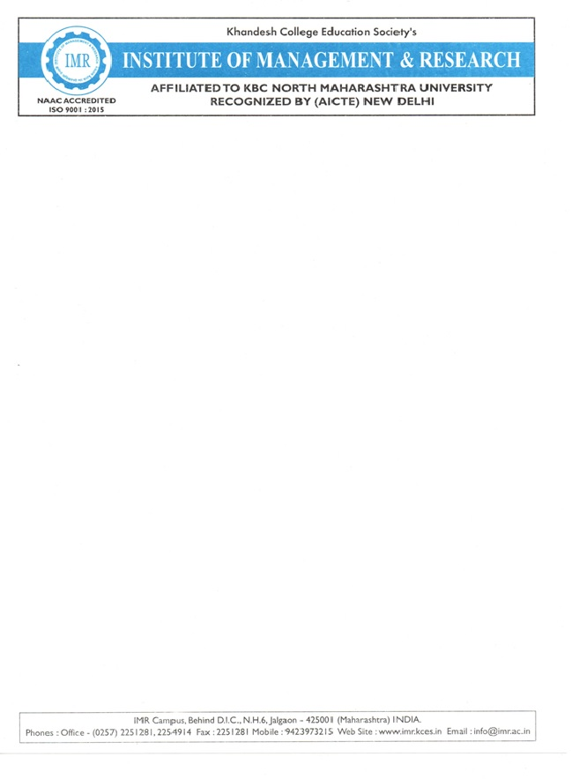

**CERTIFICATE**

This is to certify that **Ritesh Devidas Patil & : Bhatu Raju Patil** student’s of MCA(Integrated) from **KCES’S Institute of Management and Research,Jalgaon** has completed the Filed work entitled **Flipkart** both has submitted satisfactory field report in partial fulfillment of the requirement for the degree of MCA(Integrated) during academic year **2025-2026.**

It is the original work and sincerely completed the field work. I am fully satisfied

with his/there performance.

**Aarati Hinge Aarati Hinge**

**Internal Guide Coordinator**

**Dipali Kirange**

**External Examiner I / Examiner II HOD**

**ACKNOWLEDGEMENT**

We have great pleasure in submitting this Field Work on **“Flipkart”** to **Kavayitri Bahinabai Chaudhari  North Maharashtra University, Jalgaon.**

 It is humble brief that any Field Work can be carried out with success by a two person. Many other personalities helpings to accomplished this project and it is our duty to express our appreciation to them.

 We are indebted toAarati Hinge for helping us as guide and  allow us to do the Field Work at their site.

 We wish to thank the teaching staff, our friends and persons who help us directly or indirectly for completion of Field Work.

**DECLARATION**

We hereby declare that the project work entitled **“**Flipkart**”** has carried out result on the basis of investigations and analysis by us under the guidance of Aarati Hinge

 We further declare that this work has not been submitted in partly or fully to any other University or Institute for the award of any other degree. Material obtained from other source has been daily acknowledged in the Field Work.

**INDEX**

|  |  |
| --- | --- |
| **Sr. No.** | **Topic** |
| 1 | Abstract |
| 2 | Introduction |
| 3 | Project Field Work Topic / Literature Review |
| 4 | Objectives |
| 5 | Methodology |
| 6 | Result and Discussion |
| 7 | Recommendations and Future Work |
| 8 | Suggestion |
| 9 | Conclusion |
| 10 | References |
| 11 | Questionnaire |

ntroduction

The bus travel industry in India is unorganized and highly fragmented. It is a 120 billion annual turnover

industry with a growth rate of 25% per year. (Note 1) This industry is growing phenomenally in India, being one

of the most preferred modes of transport for millions of Indians. There are around 2000 private bus operators

which function with almost 20000 buses on point to point routes. (Note 2) In the Indian bus travel industry, most

of the private players were regional players and did not have a pan India presence and therefore there was a lack

of a centralized platform for organized scale of operations. The market for online car rentals and bus reservations

business was anticipated to arrive at $150 million in the year 2011 as per Applied Travel Intelligence. (Note 3)

The two carriage categories when it comes to Indian bus travel industry operations are contract carriages and

stage carriages. The contract carriages are usually long distances from city to city with less number of stop points

whereas stage carriers are comparatively short distances with several stop points. The contract carriage industry

in India is fragmented, with more than 65% of the bus operators possessing over less than 20 buses each. Despite

of growth of online ticket reservations in India through renowned players like makemytrip.com (airline) and

IRCTC.com (train), there was a reasonably slow growth when it came to online bus reservations. The role of IT

in revenue management is prominently discussed by many researchers (Kimes, 2001; Bakos, 1997). The reasons

for this slow growth could be attributed to several reasons like the unwillingness of the majority of the Indian

population to book their bus tickets online, low internet penetration and more than that, the unavailability of a

proper online platform to book their bus ticke

1. Introduction

The bus travel industry in India is unorganized and highly fragmented. It is a 120 billion annual turnover

industry with a growth rate of 25% per year. (Note 1) This industry is growing phenomenally in India, being one

of the most preferred modes of transport for millions of Indians. There are around 2000 private bus operators

which function with almost 20000 buses on point to point routes. (Note 2) In the Indian bus travel industry, most

of the private players were regional players and did not have a pan India presence and therefore there was a lack

of a centralized platform for organized scale of operations. The market for online car rentals and bus reservations

business was anticipated to arrive at $150 million in the year 2011 as per Applied Travel Intelligence. (Note 3)

The two carriage categories when it comes to Indian bus travel industry operations are contract carriages and

stage carriages. The contract carriages are usually long distances from city to city with less number of stop points

whereas stage carriers are comparatively short distances with several stop points. The contract carriage industry

in India is fragmented, with more than 65% of the bus operators possessing over less than 20 buses each. Despite

of growth of online ticket reservations in India through renowned players like makemytrip.com (airline) and

IRCTC.com (train), there was a reasonably slow growth when it came to online bus reservations. The role of IT

in revenue management is prominently discussed by many researchers (Kimes, 2001; Bakos, 1997). The reasons

for this slow growth could be attributed to several reasons like the unwillingness of the majority of the Indian

population to book their bus tickets online, low internet penetration and more than that, the unavailability of a

proper online platform to book their bus ticke

1. Introduction

The bus travel industry in India is unorganized and highly fragmented. It is a 120 billion annual turnover

industry with a growth rate of 25% per year. (Note 1) This industry is growing phenomenally in India, being one

of the most preferred modes of transport for millions of Indians. There are around 2000 private bus operators

which function with almost 20000 buses on point to point routes. (Note 2) In the Indian bus travel industry, most

of the private players were regional players and did not have a pan India presence and therefore there was a lack

of a centralized platform for organized scale of operations. The market for online car rentals and bus reservations

business was anticipated to arrive at $150 million in the year 2011 as per Applied Travel Intelligence. (Note 3)

The two carriage categories when it comes to Indian bus travel industry operations are contract carriages and

stage carriages. The contract carriages are usually long distances from city to city with less number of stop points

whereas stage carriers are comparatively short distances with several stop points. The contract carriage industry

in India is fragmented, with more than 65% of the bus operators possessing over less than 20 buses each. Despite

of growth of online ticket reservations in India through renowned players like makemytrip.com (airline) and

IRCTC.com (train), there was a reasonably slow growth when it came to online bus reservations. The role of IT

in revenue management is prominently discussed by many researchers (Kimes, 2001; Bakos, 1997). The reasons

for this slow growth could be attributed to several reasons like the unwillingness of the majority of the Indian

population to book their bus tickets online, low internet penetration and more than that, the unavailability of a

proper online platform to book their bus ticke

**Introduction**

Flipkart is one of India’s leading e-commerce companies, founded in October 2007 by Sachin Bansal and Binny Bansal, both alumni of the Indian Institute of Technology (IIT) Delhi. Originally started as an online bookstore, Flipkart quickly expanded its product range to include electronics, fashion, home essentials, groceries, and more, becoming a full-fledged online marketplace.

Headquartered in Bengaluru, Karnataka, Flipkart revolutionized online shopping in India by offering features like cash-on-delivery, easy returns, and quick delivery services, which helped build customer trust in e-commerce.

In 2018, the global retail giant Walmart Inc. acquired a majority stake in Flipkart, further strengthening its financial and operational capabilities. Today, Flipkart operates several brands and subsidiaries, including Myntra, PhonePe (earlier part of Flipkart), and Ekart (its logistics arm).

With millions of active users and sellers, Flipkart continues to play a major role in shaping India’s digital retail landscape by offering affordable products, innovative technology, and strong customer support.

**Objectives**

• **Customer Satisfaction:**  
To provide a convenient, reliable, and enjoyable online shopping experience for customers across India.

• **Wide Product Availability:**  
To offer a vast range of products across multiple categories such as electronics, fashion, home essentials, and groceries.

• **Affordable Pricing:**  
To provide competitive prices, discounts, and offers to make online shopping affordable for everyone.

• **Technology Innovation:**  
To continuously improve its platform using advanced technologies like artificial intelligence, data analytics, and automation for better user experience.

• **Support for Sellers:**  
To empower small and medium businesses by providing them with a platform to reach millions of customers nationwide.

**History**

Flipkart was founded in October 2007 by Sachin Bansal and Binny Bansal, two former Amazon employees and graduates of the Indian Institute of Technology (IIT) Delhi. The company began as a small online bookstore operating from a two-bedroom apartment in Bengaluru, Karnataka.

In its early days, Flipkart’s main focus was to make online shopping simple and trustworthy in India, where e-commerce was still new. The company gained popularity by offering cash-on-delivery and easy return policies, which helped build customer confidence.

By 2010, Flipkart expanded beyond books to include electronics, mobile phones, and fashion. Over the next few years, it launched several innovative features like one-day delivery, Flipkart First (a membership program), and its own logistics network, Ekart.

In 2014, Flipkart acquired Myntra, a leading online fashion retailer, to strengthen its presence in the fashion segment. Later, it also launched PhonePe, a digital payment platform.

A major milestone came in 2018, when Walmart Inc., the world’s largest retail company, acquired a 77% stake in Flipkart for around $16 billion, marking one of the biggest e-commerce deals in history.

Today, Flipkart is one of India’s most trusted online marketplaces, offering millions of products across diverse categories and serving customers in every corner of the country.

**Methodology:**

• Customer-Centric Approach:  
Flipkart’s entire operation revolves around customer needs and satisfaction. It focuses on offering quality products, competitive prices, and hassle-free services like easy returns and fast delivery.

• Marketplace Model:  
Flipkart operates on a marketplace model, where it connects buyers and sellers on a single online platform. Sellers list their products, and Flipkart facilitates the transactions, logistics, and customer service.

• Technology Integration:  
The platform uses advanced technologies such as Artificial Intelligence (AI), Machine Learning (ML), Big Data, and automation to improve product recommendations, personalize user experience, and optimize logistics.

• Supply Chain and Logistics Management:  
Through its logistics arm Ekart, Flipkart ensures efficient inventory management, order tracking, packaging, and timely delivery to customers across India.

• Payment and Security Systems:  
Flipkart offers multiple secure payment options including cash-on-delivery, credit/debit cards, UPI, and PhonePe, ensuring safe and flexible transactions.

**Conclusion/Result**

Flipkart has successfully transformed the way people shop in India by making online shopping simple, affordable, and reliable. From its humble beginnings as an online bookstore in 2007, it has grown into one of the largest e-commerce platforms in India, offering millions of products across diverse categories.

The company’s focus on customer satisfaction, technological innovation, and efficient logistics has helped it build strong trust among Indian consumers. Features like cash-on-delivery, easy returns, fast delivery, and affordable pricing have made it accessible to people in both urban and rural areas.

With the support of Walmart’s investment and its own strong marketplace model, Flipkart continues to expand its reach, improve its services, and promote digital commerce across the nation.

In conclusion, Flipkart stands as a symbol of India’s e-commerce revolution, driving digital transformation, empowering local sellers, and reshaping the country’s retail industry.

**Suggestion**

According to all the responses there are some major suggestion are as follows:

• Improve Customer Support:  
Flipkart can enhance its customer service by providing faster responses and better resolution for complaints and returns.

• Strengthen Quality Control:  
Stricter checks on seller listings and product authenticity can help reduce fake or low-quality items on the platform.

• Expand to Rural Areas:  
Flipkart should increase its delivery network and promotional activities in rural and remote regions to reach a larger customer base.

• Enhance Mobile App Performance:  
Optimizing the Flipkart app for low-end smartphones and slower internet connections can improve accessibility for all users.

• Promote Eco-Friendly Practices:  
Using sustainable packaging materials and electric delivery vehicles can make Flipkart more environmentally responsible.

**References**

• Flipkart Official Website – https://www.flipkart.com

• Walmart Inc. Press Release on Flipkart Acquisition (2018) – https://corporate.walmart.com

• Economic Times – Articles on Flipkart Business Growth and Market Share

• Business Standard – Reports on Flipkart’s E-commerce Operations in India

• Wikipedia – *Flipkart* (Company Profile and History) – https://en.wikipedia.org/wiki/Flipkart

**Questionnaire:**



